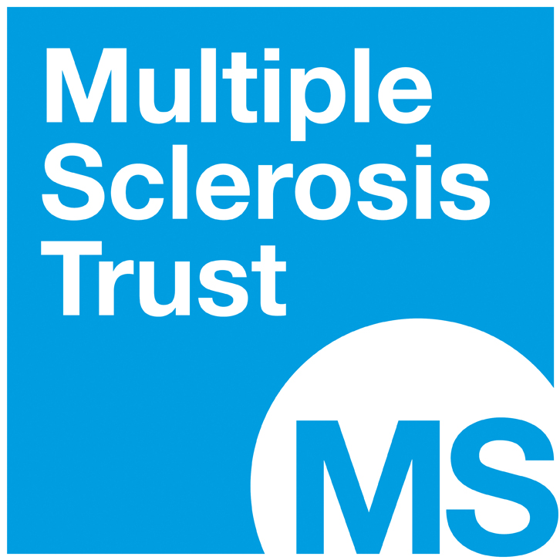

HELEN LEY BURSARY FUND
GRANT APPLICATION FORM

Name: | Address:  Postcode:
Contact no:

Email:

Job Title:

Explanation of job role (Please indicate amount of clinical contact with people with advanced MS):

Description of MS service:

Page 2

Full description of course for which funding is requested (include title, cost, date, venue, content, target audience):

Please specify amount of funding you are seeking (up to 75% of the cost of any course, with a maximum allocation of £2,000 per applicant, per year):

How do you envisage your attendance on this course will make a difference to people living with advanced MS?

Describe the potential benefit and learning outcomes and the relevance to your overall development plan including opportunities where you can use your learning to influence and improve the practice of others. (Please be specific in your answer).

Details of other possible funding source(s) that have been approached and evidence of responses:

If grant application is approved who will provide the balance of funding? (e.g. self-funding)

Signature: | Date:

Please include with this application form a copy of your CV and email to:
hpteam@mstrust.org.uk
Health Professionals Programme Team, MS Trust, Spirella Building, Bridge Road, Letchworth Garden City, Herts SG6 4ET

Reg. Charity No. 1088353

