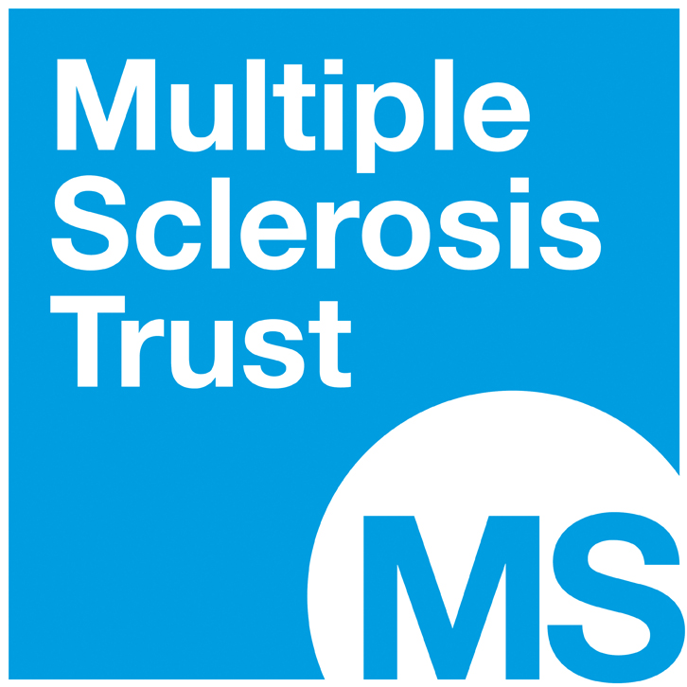

THERAPISTS EDUCATION FUND
GRANT APPLICATION FORM

Name: | Address:  Postcode:
Contact no:

Email:

Job Title:

Explanation of job role (Please indicate amount of clinical contact with people with MS):

Description of MS service:

Page 2

Full description of course for which funding is requested (include title, cost, date, venue, content, target audience):

Please specify amount of funding you are seeking (up to 75% of the cost of any course, with a maximum allocation of £2,000 per applicant, per year):
How do you envisage your attendance on this course will make a difference to people living with MS?

Describe the potential benefit and learning outcomes of the course and relevance to your overall development plan:

Details of other funding source(s) that have been approached and evidence of responses:

If grant application is approved who will provide the balance of funding? (e.g. self-funding)

Signature: | Date:

Please include with this application form a copy of your CV and email to:
hpteam@mstrust.org.uk
Health Professionals Programme Team, MS Trust, Spirella Building,
Bridge Road, Letchworth Garden City, Herts SG6 4ET

Reg. Charity No. 1088353

